“Art on the Yacht” - Registration Form

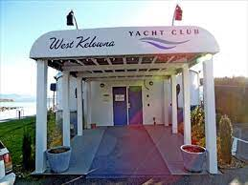 

4111 Gellatly Rd. West  **How do I spell ART? – “F-U-N”!**

Student name:Click here to enter text.

Age**:** Click here to enter text.

Parent contact**:** Click here to enter text.Parent’s phone:Click here to enter text.

Interest(s):

Water colour

Sketching

Acrylic

Mixed media

Alcohol Inks

Collage

Print Making

Air Drying Clay

Felting

Other: ­­­­­­­­­­­­­­­­­­­­­____________________

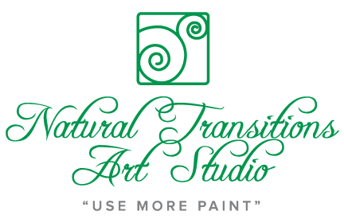email and E-transfer to: [llovisa58@gmail.com](mailto:llovisa58@gmail.com) ($35 per class)

Natural Transitions Art Studio

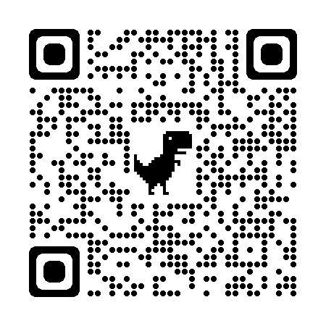

250-859-0918